ADVANCED ARTIFICIAL INTELLIGENCE PROJECTS IN DATA SCIENCE
Data-Driven Customer Profiling: Forecasting Financial Behaviour for Personalized Banking Benefits
Individual Report
Keerthana Kamalakkannan
35034195

Part A: Introduction
In this project, I focused on solving the problem of how banks can better understand customer behaviour using data. Although financial institutions collect large amounts of customer data, it is often not used effectively to generate meaningful insights. Many existing systems treat customers in a generalised way, which limits the ability to personalise services or detect risky behaviour early.
To address this a machine learning-based system was developed which analyses customer behaviour across multiple dimensions. Instead of relying on a single model, I designed a framework that looks at reward usage, psychological spending behaviour, fraud risk, and brand affinity.
This problem is important because it directly impacts both business performance and customer experience. For example, banks can improve customer engagement by offering more relevant promotions, while also reducing financial risks by identifying suspicious behaviour. At the same time, better behavioural insights allow organisations to make more informed decisions.
The main aim of this project was to build a system that not only produces predictions but also generates clear, interpretable insights that could realistically be applied in a banking environment.

Part B: Technical Review
During this project, I explored a range of data science and machine learning techniques before selecting the final approach. My focus was not only on achieving high performance but also on ensuring that the models remained interpretable and suitable for a real-world context.

Supervised Learning
I used supervised learning as the core approach, specifically classification. This involves training models on labelled data so that they can learn patterns and predict outcomes for new data. In my case, the models were designed to classify customer behaviour into categories such as high or low reward engagement, behavioural risk, fraud risk, and brand affinity.
One of the key reasons for choosing supervised learning is that it provides clear and measurable outputs, which makes it easier to evaluate model performance. It also aligns well with structured financial data, where historical patterns can be used to predict future behaviour.

Model Selection: Random Forest vs XGBoost
At the early stage of the project, I experimented with both Random Forest and XGBoost. Random Forest is a bagging-based ensemble method that builds multiple independent decision trees and combines their outputs. While it is robust and relatively easy to implement, I found that its performance plateaued when dealing with more complex behavioural relationships.
In contrast, XGBoost uses a boosting approach, where trees are built sequentially and each new tree focuses on correcting the errors of the previous ones. Through experimentation, I observed that XGBoost provided better accuracy, improved generalisation, and more consistent results across different datasets.
Another important factor was efficiency. XGBoost is optimised for speed and includes regularisation techniques that help prevent overfitting. This made it more suitable for my project, especially when working with multiple models simultaneously.

Feature Engineering
Feature engineering was one of the most important aspects of the project. Instead of relying on raw data, I transformed the dataset into meaningful behavioural indicators that better represent customer activity.
I also created composite scores, such as reward score and fraud risk score, by combining multiple features. This helped simplify complex behaviour into a single interpretable value, making it easier to apply threshold-based classification.
This process required careful consideration, as poorly designed features could reduce model performance. I tested different combinations and adjusted weights to ensure that the features accurately reflected behavioural patterns.

Categorical Encoding (One-Hot Encoding)
The dataset included categorical variables that could not be used directly by machine learning models. To handle this, I applied one-hot encoding, which converts each category into a separate binary column.
I chose this approach because it avoids introducing false numerical relationships between categories. For example, assigning numerical values to categories could imply an order that does not exist. One-hot encoding preserves the independence of categories and ensures that the model interprets them correctly. Although one-hot encoding increases the number of features, XGBoost handles high-dimensional data efficiently, so this did not negatively affect performance.

Data Normalisation
I applied MinMax scaling to transform all features into a range between 0 and 1. This was particularly important because my system relies on scoring mechanisms and threshold-based decisions.
Normalisation ensures that no single feature dominates due to scale differences. It also improves model stability and makes the outputs easier to interpret. For example, having all features within the same range allows probability scores to be more consistent across different models.

Evaluation Metrics
To evaluate the models, I used multiple metrics, including accuracy, precision, recall, and F1-score. Each metric provides a different perspective on model performance. Accuracy gives an overall measure, but it can be misleading if the dataset is imbalanced. Precision and recall provide more insight into how well the model handles positive and negative classes, while F1-score balances the two. Using a combination of these metrics allowed me to evaluate the models more thoroughly and avoid relying on a single measure.

Visualisation Techniques
Visualisation played an important role in my analysis. Feature importance plots helped me understand which variables had the most influence on predictions. Correlation heatmaps allowed me to explore relationships between different behavioural models, while scatter plots helped visualise patterns such as risk versus value. These visual tools were useful not only for analysis but also for communicating results in a more intuitive way.

Part C: Design & Implementation
System Architecture
I designed the system as a modular pipeline, where each stage performs a specific function. This approach made the system easier to manage, debug, and extend. The pipeline consists of Data cleaning, Encoding and preprocessing, Feature engineering, Model training, Evaluation, Visualisation. By separating these stages, I was able to maintain a clear structure and ensure that each component could be improved independently.

Data Preprocessing Pipeline
The preprocessing stage was essential to ensure data quality. I started by removing duplicate records to avoid bias in training. I then handled missing values using mean imputation, which allowed me to retain as much data as possible without introducing significant distortion.
Next, I converted all columns into numeric format and removed unnecessary symbols such as percentage signs. This ensured compatibility with machine learning algorithms. For categorical variables, I applied one-hot encoding. This step was integrated into the pipeline to ensure that all data entering the model was in a consistent format. Finally, I applied MinMax scaling to standardise the feature range. This completed the preprocessing stage and prepared the data for model training.

Model Design Strategy
Instead of building a single complex model, I designed four separate models, each focusing on a specific behavioural aspect. This decision was based on the idea that different types of behaviour require different modelling approaches.
The four models are: Reward Model, Psychology Model, Fraud Model, Brand Affinity Model
This modular design improves flexibility and allows each model to be analysed independently.

Training Process
For training, I used an 80/20 train-test split with stratified sampling. This ensured that the class distribution remained consistent in both training and testing sets. I also used fixed random states to ensure reproducibility. Each model was trained using XGBoost with carefully selected parameters, such as learning rate, depth, and number of estimators. This consistent training approach allowed me to compare models fairly and maintain reliability in the results.
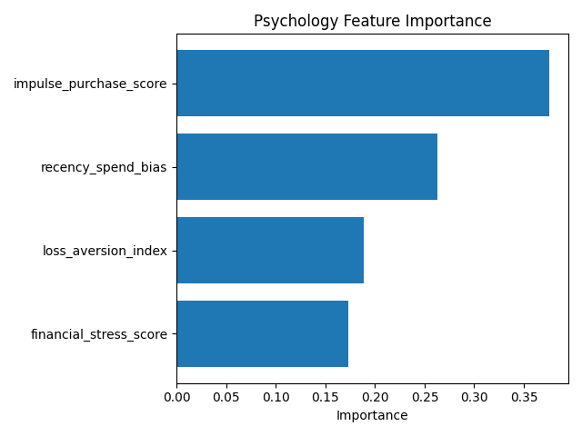

Model Persistence
After training, I saved all models and scalers using joblib. This allows the models to be reused without retraining, which is important for deployment and future development.

Part D: Technical & Critical Evaluation
Technical Evaluation
The models performed well overall, achieving high accuracy and balanced classification metrics. Through my experiments, I found that XGBoost consistently outperformed Random Forest, particularly in terms of stability and predictive performance.
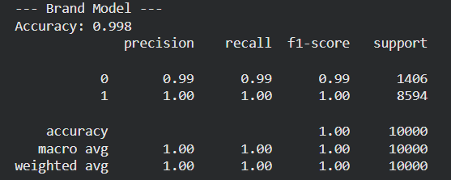
Feature importance analysis showed that reward behaviour was mainly influenced by offer-related features, fraud risk was driven by unusual transaction behaviour, and brand affinity depended on spending patterns. These findings align with real-world expectations, which increases confidence in the model outputs.
The correlation heatmap revealed relationships between different behavioural dimensions. Some behaviours, such as reward engagement and brand affinity, showed moderate correlation, while others, like fraud risk, remained largely independent. This indicates that the models are capturing distinct aspects of customer behaviour.

Critical & Social Evaluation
While the technical performance of the system is strong, I also considered the broader implications of its use.
One important concern is bias. If the dataset does not represent all customer groups equally, the model may produce unfair or inaccurate predictions. This is particularly critical in areas such as fraud detection, where incorrect classifications could have serious consequences.
Another issue is privacy. Financial data is highly sensitive, and even anonymised datasets must be handled carefully. In real-world applications, strict data protection measures and compliance with regulations would be essential. There is also a challenge related to transparency.

Part E: Project Proposal & Management
My Role
In this project, I took on both a technical and management role, which allowed me to contribute across multiple stages of the system development. One of my main responsibilities was managing the GitHub Project Board, where I organised tasks, created issues, and assigned work to team members. This helped ensure that the project progressed in a structured and trackable way, and that each member was aware of their responsibilities.
I was responsible for monitoring weekly progress, making sure tasks were being completed consistently rather than left until the end. This involved reviewing commits, checking updates, and following up when tasks were delayed. By doing this, I helped maintain steady development throughout the project rather than last-minute work.
From a technical perspective, I played a key role in dataset creation and preparation. This included cleaning the data, handling missing values, converting formats, and ensuring consistency across all features. I also performed feature engineering, where I transformed raw data into meaningful behavioural indicators, which were essential for improving model performance.
In addition, I implemented one-hot encoding for categorical variables and applied MinMax scaling to standardise the dataset. These steps were important in ensuring that the data was suitable for machine learning and that all models operated on a consistent scale.
I was also responsible for model development and selection. I trained both Random Forest and XGBoost models and compared their performance using evaluation metrics. Based on these results, I selected XGBoost as the final model due to its higher accuracy and stability. I then applied this model consistently across all four behavioural categories.
Another part of my role involved visualisation and interpretation. I generated feature importance plots, correlation heatmaps, and scatter plots to better understand the model outputs. This helped translate technical results into insights that could be more easily understood. Overall, my role combined technical implementation, decision-making, and project coordination, which helped ensure that the project was both functional and well-managed.

What Went Well
One of the main aspects that went well in this project was the use of GitHub for project management and collaboration. By using the Project Board, I was able to clearly organise tasks into different stages, such as “To Do”, “In Progress”, and “Completed”. This made it easier to track progress and ensured that no tasks were overlooked.
Another positive aspect was the clear distribution of responsibilities within the team. Assigning tasks to specific individuals helped avoid confusion and ensured accountability. It also allowed team members to focus on their areas while still contributing to the overall project.
Another area that worked well was visualisation. The use of feature importance plots, correlation heatmaps, and scatter plots helped in understanding the relationships within the data and presenting the results more clearly. These visual tools made it easier to identify patterns that might not be obvious from numerical outputs alone.
In terms of workflow, maintaining regular updates and incremental progress helped avoid last-minute pressure. By consistently working on the project and updating the repository, the development process remained steady and manageable.

Challenges
One of the main challenges I faced during this project was the lack of access to real-world financial data. Since I worked with an anonymised or synthetic dataset, it limited how accurately the models could reflect real customer behaviour. Real banking data tends to be more complex, and without it, there is always a gap between experimental results and real-world performance.
Another challenge was model tuning and maintaining consistency across all four models. Each model focused on different behavioural aspects, which required careful adjustment of features and thresholds. Balancing these differences while keeping the system consistent required multiple iterations.
From a project management perspective, coordinating team contributions was another challenge. While GitHub helped organise tasks, maintaining consistent progress required regular monitoring and communication. Finally, interpreting model outputs and translating them into meaningful insights required additional effort beyond just evaluating performance metrics.

Future Work
If I were to continue this project, I would focus on several improvements. One key area is integrating real-time data, as the current system is based on static data. This would make the model more dynamic and relevant in real-world applications. I would also implement explainability techniques such as SHAP to improve transparency and provide deeper insights into model predictions.
Another improvement would be exploring more advanced models, including deep learning approaches, to capture more complex patterns. From a system perspective, I would develop an interactive dashboard to allow users to explore customer profiles more easily. I would also consider adding a recommendation system to provide personalised insights and suggestions. Finally, I would work on integrating the system with external platforms through APIs and ensuring scalability using cloud infrastructure.

Part F: Conclusion
In this project, I developed a machine learning system to analyse customer behaviour across multiple dimensions. By combining four separate models, I was able to create a more comprehensive and structured view of customer profiles. The use of XGBoost resulted in strong predictive performance, while visualisations helped improve interpretability. The modular design of the system also makes it flexible and suitable for future extensions.
At the same time, the project highlighted important challenges and ethical considerations, including bias, privacy, and transparency. Addressing these issues is essential for applying such systems in real-world environments.
Overall, this project demonstrates how machine learning can be used to support more personalised and data-driven decision-making in banking, while also emphasising the importance of responsible AI development.

